Elementary Guidance Lesson Plan

Counselor: Tiffany Schuette

Lesson: #2

Unit: Self-Esteem & Academic Success

Title: Get Into a Growth Mindset

Grade Level: Second & Third

Time: 30-60 Minutes

Learning Target:
I can understand the meaning of a closed and open mindset.

Materials:
- Mindset pre- and post- survey
- “The Dot” by Peter Reynolds – Book
- Document camera for the book
- Computer for videos
- Lesson adapted from: http://theschoolcounselorkind.wordpress.com/tag/closed-mindset/

Learning Activities:
- Tell students that we are going to take a pre- and post- test to see how much you know now and how much you learned afterwards. Explain that it is not a test you get graded on, it’s a just so we can see how much you learned. Administer the mindset pre-test and read each item aloud with students and collect.
- Write the word mindset on the board and allow students to guess what it means. They may say: “when your mind is set on something” and “how your mind thinks about things.”
- Talk about closed vs. open mindset and write it on the board. Pair students up and give them a minute to discuss the difference. Possible responses: “open is when you’re thinking about things, closed is when you’re not” and “open is when you want to talk about something, closed is when you aren’t willing to talk about things.”
- Explain that when someone is in a closed mindset they give up easily, they don’t try things that might be hard, and they don’t believe that they can learn. Give a few examples of what someone with a closed mindset would say: “This math is too hard,” “I can’t do this,” “I’m not going to try,” “I can’t make any friends,” and “No one here helps me.” Ask them how well someone with that kind of mindset would learn; not very well at all!
- When someone has an open mindset they don’t give up, they believe they can learn and that, in a sense, their brain can grow. Give a few examples of what someone with an open mindset would say: “This math is hard, but I’m going to keep trying,” “I can do this,” and “I don’t have any friends….yet.” Students with this kind of mindset would learn much better. Discuss the power of yet - adding yet onto the end of a sentence can make all the difference!
- Practice the sign for each mindset:
  - (closed on the left, open on the right with fingers wiggling)


- Explain open/closed mindset as growth/fixed and write it on the board.
- Growth Mindset video: https://www.youtube.com/watch?v=ElVUqv0v1EE
- Kids talk about Growth Mindset and hard work. https://www.youtube.com/watch?v=Sixp6QJP9rM&list=PLhi80miGmnEC9_QT6bQsOPH9sjbFE9hwe
- Read “The Dot” by Peter Reynolds to discuss the mindset of each character and how the mindset of little Vashti changed over the course of the story.
- Ornie the Pig in the growth mindset: https://www.youtube.com/watch?v=xd63g3d8qOs
- Sesame Street: Bruno Mars: Don’t Give Up: https://www.youtube.com/watch?v=pWp6kkz-pnQ&list=PLpzLAWxRHSdA4iTpa5N2kxDaeGd5-25p9&index=4
- Post the Mindset Visual on the board and as a class go through the “What Can I Say to Myself?” chart.

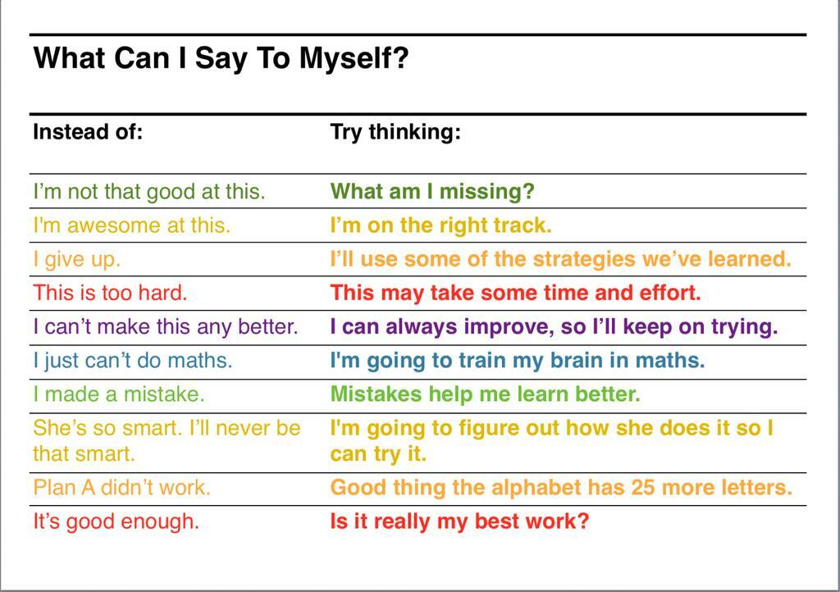
- Kid Gives Speech After Learning How to Ride a Bike: https://www.youtube.com/watch?v=P0zVPZBykSE&index=7&list=PLpzLAWxRHSdA4iTpa5N2kxDaeGd5-25p9
- Finding Nemo: Just Keep Swimming: https://www.youtube.com/watch?v=AsemWIZUk4k&index=10&list=PLpzLAWxRHSdA4iTpa5N2kxDaeGd5-25p9
- In closure, ask students what an open mindset is and elicit responses. Ask what a closed mindset is and elicit responses. Ask: Can anyone learn even if something is hard? Administer the mindset post-test, read each item aloud with students and collect.

